
Highvale Primary School
STATEMENT OF VALUES AND SCHOOL PHILISOPHY

Reviewed: March 2026 Next Review: March 2029
Review Cycle: 3-4 years
Communication Method: Website, Newsletter, Compass School Documentation
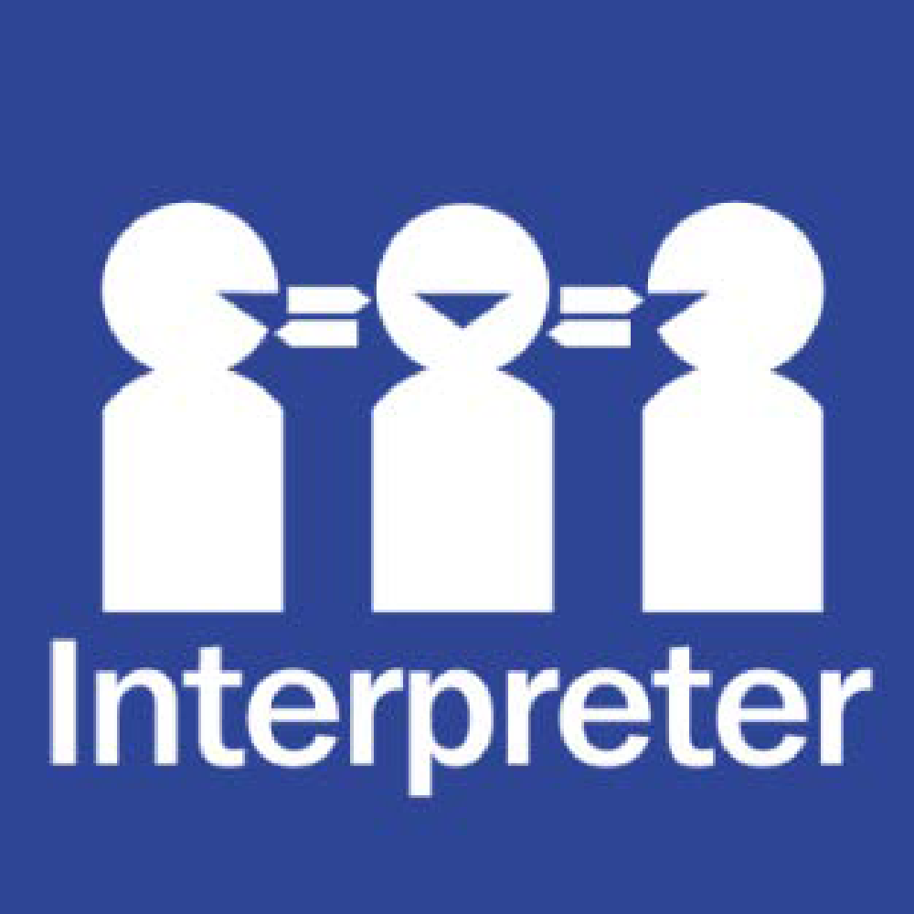
Help for non-English speakers
If you need help to understand the information in this policy, please contact the School Office on 9887 8000.

PURPOSE
The purpose of this policy is to outline the values of our school community and explain the vision, mission and objectives of our school.

POLICY
Highvale Primary School is committed to providing a safe, supportive and inclusive environment for all students, staff and members of our community. Our school recognises the importance of the partnership between our school and parents and carers to support student learning, engagement and wellbeing. We share a commitment to, and a responsibility for, creating an inclusive and safe school environment for our students.
The programs and teaching at Highvale Primary School support and promote the principles and practice of Australian democracy, including a commitment to:
- elected government
- the rule of law
- equal rights for all before the law
- freedom of religion
- freedom of speech and association
- the values of openness and tolerance.
This policy outlines our school’s vision, mission, objective, values and expectations of our school community. This policy is available on our school website, our staff induction handbook and enrolment/transition packs.
To celebrate and embed our Statement of Values and School Philosophy in our school community, we
- display posters and banners that promote our values in our school
- celebrate our values in our school newsletter
- provide awards and recognition for students who actively demonstrate our values
- discuss our values with students in the classroom, meetings and assemblies.

VISION
Highvale Primary Schools vision is to empower students to experience challenge, develop independence and achieve success.

MISSION
Highvale Primary School’s mission is to work together with our globally diverse community to nurture engaged, socially responsible and resilient learners. Students are empowered to experience challenge, develop independence and achieve success. Our practice:
- Places students at the centre of all decision making.
- Is always informed by evidence and research.
- Includes high expectations of our students, staff and community.
- Creates a safe, inclusive learning environment for everyone

OBJECTIVE

Our school’s objectives are considered as part of the 4 yearly strategic planning process and reflected in the goals listed in our current School Strategic Plan (SSP). We also develop an Annual Implementation Plan to operationalise the goals and key improvement strategies contained in our SSP.

VALUES
Highvale Primary School’s values are Respect, Responsibility, Honesty & Integrity and Commitment.
BEHAVIOURAL EXPECTATIONS
Highvale Primary School acknowledges that the behaviour of staff, parents, carers and students has an impact on our school community and culture.
We acknowledge a shared responsibility to create a positive learning environment for the children and young people at our school.
Shared expectations of staff, parents, carers and students to support positive student behaviour are set out in the Respectful, safe, engaged: shared expectations to support student behaviour statement.
Students are also supported by school staff to meet expected standards of behaviour as outlined in our Student Wellbeing and Engagement Policy, Inclusion and Diversity Policy, and Bullying Prevention Policy
Staff must follow our school and department policies and the Victorian Public Service Code of Conduct and Values. Teaching staff also adhere to the Victorian Teaching Profession's Code of Conduct.
Parents and carers play a vital role in helping their child understand and meet shared behaviour expectations. Additionally, information about the expectations of parents and carers to ensure schools remain respectful and inclusive places is outlined in the department’s Respectful Behaviours within the School Community Policy, and our Respect for School Staff Policy. Schools can share these expectations through use of posters available in over 30 translated languages.

UNREASONABLE BEHAVIOURS
Schools are not public places, and the principal has the right to permit or deny entry to school grounds (for more information, see our Visitors Policy).
Unreasonable behaviour demonstrated by school staff, parents, carers, students or members of our school community is not tolerated at school, or during school activities.
Unreasonable behaviour includes:
- being violent or threatening violence of any kind, including physically intimidating behaviour such as aggressive hand gestures or invading another person’s personal space
- speaking or behaving in a rude, aggressive or threatening way, either in person, via email, social media, or over the telephone
- sending demanding, rude, confronting or threatening letters, emails or text messages
- discriminatory or derogatory comments
- the use of social media or public forums to make inappropriate or threatening remarks about the school, staff or students.

Harassment, bullying, violence, aggression, threatening behaviour and unlawful discrimination are unacceptable and is not tolerated at our school.

Unreasonable behaviour and/or failure to uphold the principles of this Statement of Values and School Philosophy may lead to further investigation and the implementation of appropriate consequences by the principal.
At the principal’s discretion, unreasonable behaviour may be managed by:
- requesting that the parties attend a mediation or counselling sessions
- implementing specific communication protocols
- written warnings
- conditions of entry to school grounds or school activities
- exclusion from school grounds or attendance at school activities
- reports to Victoria Police
- legal action.

Inappropriate student behaviour will be managed in accordance with our school’s Student Wellbeing and Engagement Policy and Bullying Prevention Policy.

Our Statement of Values and School Philosophy ensures that everyone in our school community is treated with fairness and respect. In turn, we strive to create a school that is inclusive and safe, where everyone is empowered to participate and learn.

COMMUNICATION

This policy is communicated to our school community in the following ways:

- Available publicly on our school’s website
- Included in staff induction processes and the staff handbook
- Included in staff handbook/manual
- Included in transition and enrolment packs
- Included as an annual reference in the school newsletter
- Made available in hard copy from school admin upon request

RELATED POLICIES AND RESOURCES
Department of Education policies and resources:
- Work-Related Violence in Schools Policy
- Respectful Behaviours within the School Community Policy
- Respectful, safe, engaged: shared expectations to support student behaviour
Highvale Primary School polices:
- Bullying Prevention Policy
- Inclusion and Diversity Policy
- Parent Complaints Policy
- Student Wellbeing and Engagement Policy

POLICY REVIEW AND APPROVAL

Policy last reviewed | March 2026
Approved by | School Council
Consultation | Staff – February  School Council - March
Next scheduled review date | March 2029

